TOPIC 2: SETS
We have become very familiar with the concepts of association and grouping in the world we live in. We seek to always find a place we belong in, a group we move with, a football club we support, an ideology we embrace.
In this day and age, each and everyone forms a part of some collective, and is referred to as a member of that collective. These collectives are referred to as sets.
Objectives:
At the end of this session, the student will be able to;
- Explain and identify different types of sets.
- Solve questions using algebraic sets
- Solve questions and calculate required values using the Venn Diagram
A set is a collection of well-defined elements. These elements can be numbers, components, colors, shapes or any sort that can be easily classified together. The set is usually denoted by Capital Letters.
There are two basic ways for writing sets and its elements.
- Listing Form:
Here, all the individual elements in the sets are written in full and separated by commas i.e. “,”
Example
A = {1,2,3,4}
Shapes = {square, rectangle, circle}
The listing form can be also be used to represent the elements in a Mathematical Tool Set.

TRIVIA:
In the case where the elements become so numerous, but are following a particular pattern or sequence, the elements are continued with an ellipsis i.e. “….”
Example
Set of natural numbers, $N$= {1,2,3, 4…}
Set of integers, ℤ = {…., -3, -2, -1, 0, 1, 2, 3, ….}
B = {1, 2, 3, …., 13} = {1, 2, 3, 4, 5, 6, 7, 8, 9, 10, 11, 12, 13}

NOTE:
- For sets like $N and Z$where the ellipsis falls at the end of the set form, with no last term, they are sets that continue infinitely, and are called INFINITE SETS. Other examples include Q, $Q^{c}$, $R$, etc.
- For sets like A and B and the maths’ set, they are termed FINITE SETS, as all their elements including the last or first member is known.

- Set Builder Form
This form is also known as the organizational form. In this case, the set is written in formula form, and employs the use of a lot of symbols.
Example
A = {1,2,3, 4, 5} in listing form can be written as
A = {$ϰℇN /$ 1 $≤x ≤5\}$ in set builder form

To this effect, it in necessary to discuss the symbols used in set builder form, so as to fully understand the concept.
- “$ϵ$”
This symbol mathematically means “belongs to”, “is an element of “or “is a member of”. It is used to express the fact that an element (written before the symbol) is a member of a particular set (written after the symbol).

- “I” or “:”
This symbol mathematically means “such that”. It is used to express the characteristics of the element in question.
For instances, an English Sentence “Ade is Nigerian with a height between 10cm and 20cm” can be translated in set builder from as
{Ade $ϵ$ Nigeria: 10cm $≤Ade^{'}s height ≤20cm$
The height is simply a characteristic of Ade
Similarly,
A = {x $ϵ N$ / 1 $ϵ x ≤5\}$ can be read as
“A is a set containing elements from 1 to 5 that are natural numbers”; or “A is a set containing elements that are natural numbers such that these elements range from 1 to 5”.
Example:
$N=\{x/x ≥1 or \{x ϵ Z/x≥1$
A = {x/x is an even number}
Other than theses two symbols, there are a couple that can be used in set forms.
- “$⊂$”
This mathematically, means “is a subset of”. It is used to express the fact that a set is “completely contained” in another set. The other set is usually bigger or at the very least, equivalent.
Example:
A$⊂$B means that A is completely contained in B
- “$⊃$”
This is referred to as the containment symbol. It is used to express the fact a set “completely contains” another set.
Example
A$⊃$B means that A completely contains B. Thus, it implies that A is the bigger set.

TYPES OF SETS
Based on their purpose, or the symbol representing them, there are different types of sets that exist.
- UNIVERSAL SET
This is the set containing all the other sets attributed to it. The universal set is hugely dependent on the problem being solved and is the biggest set within that problem. It is denoted as “U”.

- EMPTY SET
This is the set that contains nothing. As such, it is contained in every other set that exists. It is denoted by “$∅ or \{\}$.
- SUBSET
This is the set in which all its elements are contained in another set. It is portion of the larger whole or universal set.
Example:
An example of a subset is a classroom in an entire school.
- UNION OF SETS
This is a set derived from the combination of two or more sets. All the members of the individual sets are written, with No repetitions allowed. It utilizes the symbol “U” to signify union.
Example
A = {1,2,3,4,5,6}
B = {2,4,6,8,10}
AUB = {1,2,3,4,5,6,8,10}
- INTERSECTION OF SETS
This is a set derived by the selection of common elements from two or more sets. Only members that appear in all the individual sets are selected. It utilizes the symbol “∩” to signify intersection.
Example
A = {1, 2,3,4,5,6}
B = {2,4,6,8,10}
A∩B = {2,4,6}
- DIFFERENCE OF SETS
Just as the name implies, it is a set derived from the difference between two sets. The symbol utilized is ‘-’
The difference set A-B is a set containing elements in A that are not in B.
Example
A = {1, 2,3,4,5,6}
B = {2,4,6,8,10}
A-B = {1,3,5}
B-A= {8,10}
It follows that B-A is a set containing elements in B that are not in A. There is no emphasis on the need for a bigger set, as far as difference is concerned.
- COMPLIMENT OF A SET
This set is derived from comparisons between a set and the universal set. The compliment of a set, say A, written as “A” or “$A^{c}$” is the set containing elements in the universal set, but are not in A.
Example
Let $∪$= {1,2,3,………,10} = {1,2,3,4,5,6,7,8,9,10}
A= {1,2,3,4,5}
Then, $A^{c}$ = {6,7,8,9,10}
Essentially, $A^{c}$ = $∪$-A and AU$A^{c}$= $∪$; A∩ $A^{c}$ = $∅$
TRIVIA
The set of even numbers is a compliment of the set of odd numbers, with the universal set being $N.$
In fact, ${ ∅}^{c}$ = U and $U^{c}$ = $∅$
- DISJOINTS
This refers to sets that have nothing in common, or their intersection is empty.
Example
A = {1,2,3}
B = {4,5,6}
A ∩ B = $∅$
Then, A and B are disjoint
Similarly, the sets of even and odd numbers are disjoint.
Essentially, two sets are said to be disjoint if their different sets are empty. That is for instance,
A = {1,2,3}
B = {4,5,6}
A - B = $∅$; B -A = $∅$
Since A - B = B -A = $∅$, then A and B are disjoint
- SINGLETON SET
This is a set that contains only one single element.
Examples
A = {1} ; B = {x}
C = {x $ϵ N$ : $x^{3}$ = 27

GENERAL EXAMPLES
- Let P = {1,2, u,v,w,x}
Q = {2,3,v,w,5,6,y}
R = {2,3,4,v,x,y}
- Determine P – Q
P – Q = {1,u, x}
- Determine (P-Q) ∩ R
Since P – Q = {1,u,x}
And R = {2,3,4,v,x,y}
(P-Q) ∩R = {x} so, (P-Q) ∩ R is a singleton set.

- Let U = {x $ϵ N$ / 1 $≤x≤12\}$
P = {1,3,5,7,9,11}
R = {1,2,5,8,10,11}
Q = {2,4,6,8,10,12}
- Determine the relationship between P and Q
Since P ∩ Q = $∅$
- Determine ${(P∩R)}^{c}$
$$P∩R=\left\{1,5,11\right\}$$
$${\left(P∩R\right)}^{c}=U-\left(P∩R\right)=\left\{2,3,46,7,8,9,10,11\right\}$$
- Determine ${(Q∪R)}^{c}$
$$\left(Q∪R\right)=\left\{1,2,4,5,6,8,10,11,12\right\}$$
$${\left(Q∪R\right)}^{c}=U- \left(Q∪R\right)=\left\{3,7,9\right\}$$

VENN DIAGRAMS
These are diagrammatic or shape representations of sets. When utilized properly, they can ease out the answer to any set structure.
KEY REPRESENTATIONS
- UNIVERSAL SET
U



OR

The universal set is represented by the Rectangle shape. Within it lies all other subsets and elements of the set.
- PROPER SETS

Proper sets are sets that are completely contained in the universal set and are well defined. In general, there are two IMPROPER SETS. These are U and $∅,$ since U is not completely contained in itself, but is in fact equal; and $∅$ is not well defined within U, since it has no elements.
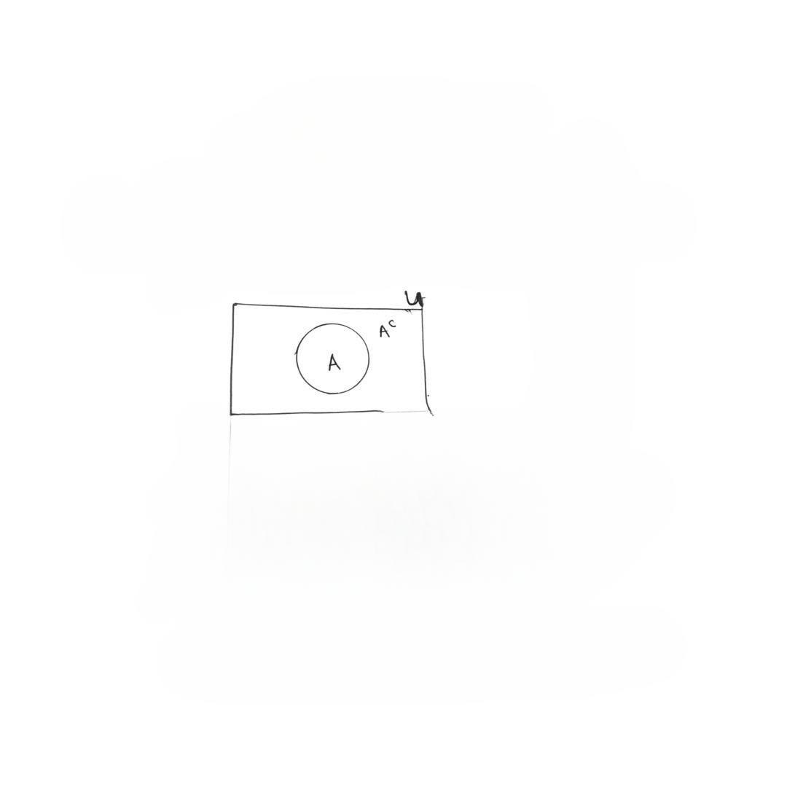

- SUBSETS

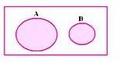  A | 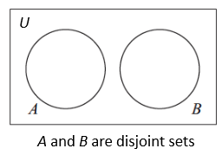 | 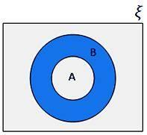

- CARDINALITY
This refers to the number of elements in a set.
Example:
A = {1,2,3,4,5,6,9,10}
n(A) = 8 means there are 8 elements in set A.
The cardinality is the displayed numeric values within a venn diagram when solving a problem.
Example:
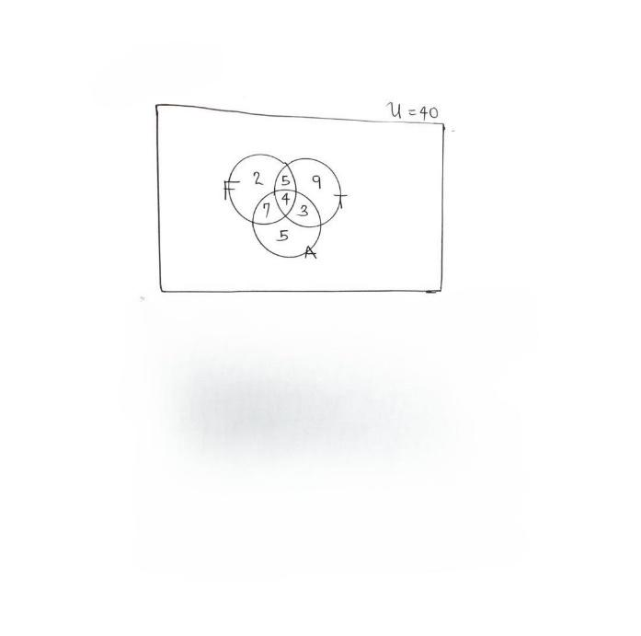

The venn diagram shows a class of 40 students with the games they play, F for Football, T for Tennis and A for Athletics.
- How many students play all the games?
n(F ∩ T ∩ A) = 4 is the spot where all the circles intersect.
- How many students play ONLY one game?
n(F) = 2 students play only Football
n(T) = 9 students play only Tennis
n(A) = 5 students play only Athletics
So, n(F) + n(T) + n(A) = 2+9+5=16 students play Only one game.
- How many students play ONLY two games?

n(F∩T) = 5 students play Football and Tennis only
n(F∩A) = 7 students play Football and Athletics only
n(T∩A) = 3 students play Tennis and Athletics
so, n(F∩T) + n(F∩A) + n(T∩A) = 5 + 7 + 3= 15 students play only two games.
WORKED EXAMPLES
- If X = {$n^{2}+1 :n is a positive integer and 1≤n≤5\}$
Y = {5n $:n is a positive integer and 1≤n≤5\}$
- Find X $∪Y$
- Find X ∩ Y
- If Q is a factor of 18 and T is a prime number between 2 and 18, with the bounds inclusive, what is Q ∩ T?
- If U = {1,2,3,…..,10}
N = {set of even numbers within U}
Find $N^{1}$

- In a school of 150 students, 80 offers French, while 60 offers Arabic and 20 offers neither. How many students offer both subjects?

RECOMMENDATION
Mathematical Tool Set

SOLUTION TO WORKED EXAMPLES:
X = {$n^{2}+1 :n ε Z^{+} and 1≤n≤5\}$
So n picks values 1,2,3,4,5. Replace n with these values in $n^{2}+1.$We have that
X={2,5,10,17,26}
Y = {5n $:n ε Z^{+}and 1≤n≤5\}$
So n picks values 1,2,3,4,5. Replace n with these values in 5n. We have that
Y = {5,10,15,20,25}

- X $∪Y$ = {2, 5, 10, 15, 17, 20, 25, 26}
- X ∩ Y= {5,10}
- Q = {factor of 18} = {1,2,3,6,9,18}
T = {x is prime: 2 $≤x≤18\}=\{2,3,5,7,11,13,17\}$
Q∩T = {2,3}
- U = {1,2,3,….,10}
N= {Set of even numbers within U} = {2,4,6,8,10}
$$N^{1}=\left\{1,3,5,7,9\right\}=\left\{set of odd numbers within U\right\}$$
- n(F) + n(A) + n(F∩A) + n($∅)=150$
80-x+60-x+x+20 = 150
160-x = 150
x = 10 students
thus, 10 students offer both French and Arabic
